**Height of the Mounting Point: 85 cm**

Boundary box

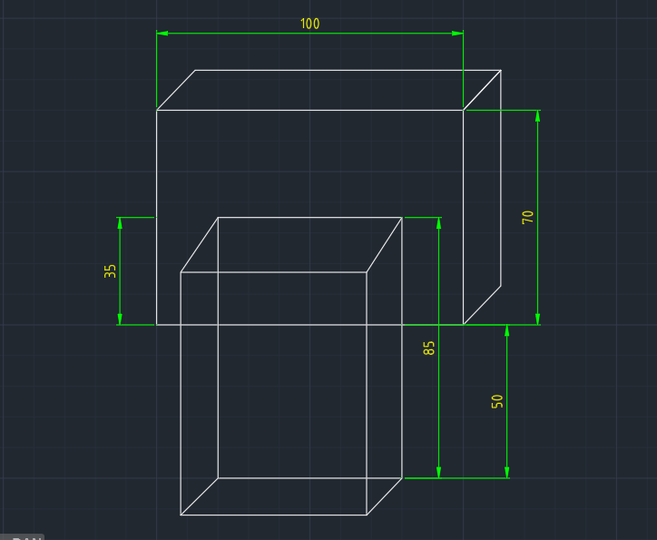

Mounting point

The reasons for choosing 85 cm to be the appropriate height for the mounting point are:

* Horizontal line at 85 cm from the ground is the horizontal centre line of the boundary box. The end effector is to be kept aimed at the centre point of the boundary box.
* For the given coordinates of the charging port in the boundary box, the centre point of the box will be equidistant in all directions. This means that the robot’s end effector (charging end) will have to cover a minimum distance in a given direction if it is initially, resting at some distance in front of the boundary box aiming at the centre point.
* As we are reaching our point by covering the minimum possible distance, eventually we are also doing minimum or optimal power consumption for completing that single cycle. Also from the centre, we are doing the minimum possible work against gravity whether it is moving upward or down from the initial or resting position at the mounting point.

For example, we know that an aircraft consumes most of its fuel during the Climb and Landing and the power consumption is nearly stable when it is flying at a constant altitude neglecting the wings’ thrusts compared to flight per minute.

Similarly, when the robotic charging arm does most of its motion unidirectionally, it will consume less power.

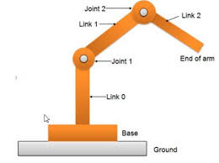

As shown in the figure, link 2, having to charge the end effector will translate horizontally to the center point of the boundary box and then move to the detected coordinates of the charging port on the vehicle.

* Working of joints and links with these lengths and specifications is more decent.
* While choosing mount height one more thing can be considered we can take mount height considering the standard height of the charging points of most of the vehicles.